**Enviro365 Business Analysis Graduate Programme**

**Scenario 1 Answers**

1. Functional decomposition diagram

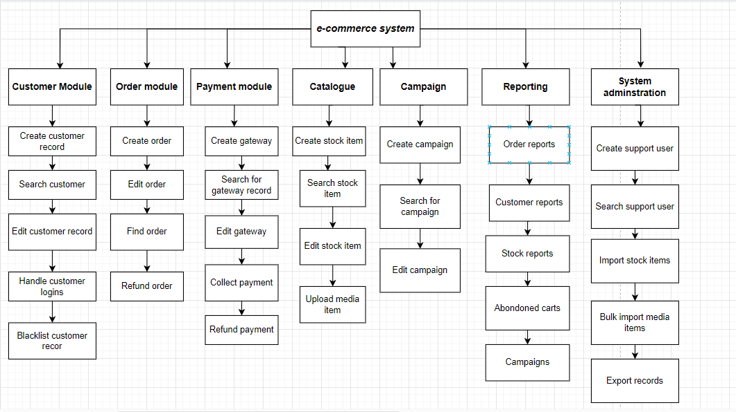

1. User interface

*Order Management:*

For order management, create a **dashboard-style interface** where customer service representatives (CSRs) can view a list of orders. Customers can search for orders by various criteria such as order ID, customer name, date range, etc. They can also click on an order to view its details and make any necessary edits such as updating the order status or processing refunds.

**Scenario 2 Answers**

1. **Detail user story**

User Story Workshop:

* Collaborative workshops are organized with stakeholders to identify and prioritize user stories based on RFP requirements.
* Techniques like story mapping are employed to visualize the user journey and prioritize features effectively.

User Interviews:

* One-on-one or group interviews with students, faculty, and administrative staff are conducted to understand their needs and pain points.
* The focus is on gathering insights specific to purchasing monthly parking passes online.

Observation:

* Observations are made as students navigate the current parking pass purchasing process, whether physically or through the existing system.
* Challenges, inefficiencies, and areas for improvement in the current process are noted.

Feedback Sessions:

* Focus groups or feedback sessions with students are organized to gather input on preferences and expectations for an online parking pass system.
* Open discussions are encouraged to gather feedback on features, usability, and desired functionalities.

Prototype Review:

* Prototypes or mock-ups of the proposed parking pass purchasing feature are developed.
* Usability testing sessions with students and stakeholders are conducted to gather feedback and iterate on the design accordingly.

1. **Questions for requirements**

*Can you describe the current process for purchasing monthly parking passes in detail?*

* Understand the step-by-step process, including where and how students currently apply, pay, and receive their parking passes.

*What are the main pain points or challenges students encounter when purchasing parking passes?*

* Identify any frustrations, delays, or difficulties students face during the current process.

*How frequently do students need to purchase or renew parking passes?*

* Determine if passes are typically purchased monthly, per semester, or annually, and whether there are recurring patterns or deadlines.

*What payment methods do students prefer or have access to for purchasing parking passes?*

* Explore whether students prefer online payment options, credit/debit cards, mobile payment apps, or other methods.

*Are there any specific parking zones or permit types that students need to select when purchasing passes?*

* Determine if students need to choose specific parking zones or permit types based on their needs or eligibility.

*What information do students need to provide when purchasing parking passes online?*

* Gather requirements for student identification, vehicle registration, contact information, or any other relevant details.

*How do students receive their parking passes after purchasing them online?*

* Clarify whether passes are delivered electronically (e.g., email, mobile app) or if there's a physical pickup process.

*Are there any accessibility requirements or considerations for students with disabilities or special needs?*

* Ensure that the online parking pass system is accessible and inclusive for all students, including those with disabilities.

*What features or functionalities would students find valuable in an online parking pass system?*

* Explore additional features such as pass renewal reminders, account management tools, or integration with campus navigation apps.

**Scenario 3**

As a business analyst, my role is multifaceted and pivotal in ensuring the success of software development projects. Here's a breakdown of my responsibilities and contributions throughout the software development life cycle (SDLC):

1. Understanding Client Needs:
   * One of my primary responsibilities is to engage with clients and stakeholders to understand their business objectives, challenges, and requirements.
   * I conduct interviews, workshops, and meetings to gather and document requirements, ensuring a comprehensive understanding of the project scope.
2. Analysing Requirements:
   * I analyse the gathered requirements to identify key features, functionalities, and business rules.
   * Through careful analysis, I ensure that the requirements are clear, concise, and aligned with the client's goals.
3. Translating Requirements into Solutions:
   * I collaborate closely with designers, developers, and other stakeholders to translate requirements into technical specifications and design documents.
   * By bridging the gap between business needs and technical solutions, I ensure that the proposed solution meets the client's requirements and expectations.
4. Facilitating Communication:
   * I serve as a communication hub between different stakeholders, ensuring that everyone is aligned and informed throughout the project.
   * I facilitate meetings, clarify requirements, and address any issues or concerns that arise during the development process.
5. Quality Assurance and Testing:
   * I participate in quality assurance activities by reviewing deliverables, conducting user acceptance testing, and ensuring that the solution meets the defined acceptance criteria.
   * I work closely with the testing team to identify and resolve any defects or issues, ensuring a high-quality final product.
6. Change Management:
   * I manage change requests and enhancements throughout the project, evaluating their impact on scope, schedule, and budget.
   * I prioritize changes based on their importance to the client's objectives and negotiate with stakeholders to reach consensus on proposed changes.
7. Training and Support:
   * I develop training materials and conduct training sessions for end-users to ensure a smooth transition to the new system.
   * I provide ongoing support and assistance to users, addressing any questions or concerns that arise after implementation.
8. Continuous Improvement:
   * I proactively identify areas for improvement in processes, systems, and workflows.
   * I collect feedback from stakeholders, analyse lessons learned from past projects, and recommend enhancements to optimize project delivery and outcomes.

**Scenario 4 Answers**

|  |  |  |  |
| --- | --- | --- | --- |
| **Entity name:** | **Customer** |  |  |
| **Attribute:** | **Key(PK/FK)** | **Data type** | **Data size** |
| Customer ID | PK | Integer | 255 |
| Create date(when the ‘Customer’ record was created) |  | Date | 10 |
| Status(e.g Good, Blacklisted) |  | Varchar | 20 |
| First name |  | Varchar | 255 |
| Last name |  | Varchar | 255 |
| Email |  | Varchar | 255 |
| Cell phone |  | Varchar | 13 |
| Date of birth |  | Date | 10 |
| Address line 1 |  | Varchar | 255 |
| Zip code |  | Integer | 10 |
| Gender(e.g Female, Unkown) |  | Varchar | 10 |

|  |  |  |  |
| --- | --- | --- | --- |
| **Entity name:** | **Order** |  |  |
| **Attribute** | **Key(PK/FK)** | **Data type** | **Data size** |
| Order ID | PK | Integer | 225 |
| Create date(when cart record was created) |  | Date | 10 |
| Status |  | Varchar | 255 |
| Order date |  | Date | 10 |
| Customer ID | FK | Integer | 255 |
| Total pre-tax value |  | Decimal | 10 |
| Total tax value |  | Decimal | 10 |
| Total order value |  | Decimal | 10 |
| Total quantity of products |  | Integer | 255 |